**Installation**

**Step by Step Instruction for Appium Configuration in Windows/MAC**

* Download Java(JDK).
* Download Android Studio & find out Android SDK Path.
* Download NodeJS.
* Set (Java, Android SDK, Node) Home paths in Windows System variables.
* Set (Java, Android SDK, Node) Home paths in Mac OS System variables.
* Open Android Studio & Configure Emulator.
* Install & start Appium server via Node.
* Install Eclipse Editor.
* Understand the Desired capabilities to setup the environment in the Appium.
* Appium First program to invoke the Android Apps.

**Install JAVA JDK and configure environment variables**

* + Command to check if JAVA is already installed: java -version
  + JAVA JDK download link: https://www.oracle.com/technetwork/java/javase/downloads/index.html
  + Create JAVA_HOME system environment variable and set it to JDK path (without bin folder).
* Edit PATH system environment variable and add %JAVA_HOME%\bin
* Note: Usually JDK path is "C:\Program Files\Java\<your_jdk_version>"

**Configuring Android Studio**

* Select New Project 🡪 Select No Activity Layout 🡪 Click on Continue 🡪 Search/Select SDK Manager 🡪 Copy SDK Path 🡪 Install Android Versions
* Add the SDK Path in System Environment Variable
* User Variables

ANDROID_HOME C:\Users\HI\AppData\Local\Android\Sdk

* System Variables
* C:\Users\HI\AppData\Local\Android\Sdk\platform-tools
* C:\Users\HI\AppData\Local\Android\Sdk\tools\bin
* C:\Users\HI\AppData\Local\Android\Sdk\tools
* Check in CMD using command “adb devices”

**Install Appium Command Line Interface (CLI) server**

* + Commands to check if node and NPM (Node Package Manager) are installed:
* node -v
* npm -v
  + Install node.js (NPM is included) from link - https://nodejs.org/en/download/
* Important note: Use the LTS and not current version.
* Adding NodeJS Path(Node version should be 16 or above)

System Variables

C:\Program Files\nodejs\

* + Command to install Appium using npm: npm install -g appium@next
* Note: @next will not be required once Appium 2.0 stable release is out to market.
  + Command to install specific version: npm install -g appium@<verion_number>
  + Command to start Appium: appium
  + Command to get installation location: where appium
  + Command to uninstall Appium: npm uninstall -g Appium
  + To stop server use taskkill /F /IM node.exe

**Install UiAutomator2 driver (using Appium CLI)**

* Get help: appium driver --help (or -h)
* Get list of officially supported drivers: appium driver list
* Install driver: appium driver install uiautomator2
* Install driver with specific version: appium driver install uiautomator2@<version_number>

**Emulator Setup: Accelerate Performance**

* Launch Android Studio -> SDK Manager -> SDK Tools
* Intel processor: Check "Intel x86 Emulator Accelerator (HAXM Installer)" and Apply
* AMD processor: Check "Android Emulator Hypervisor Driver for AMD Processors (installer)" and Apply

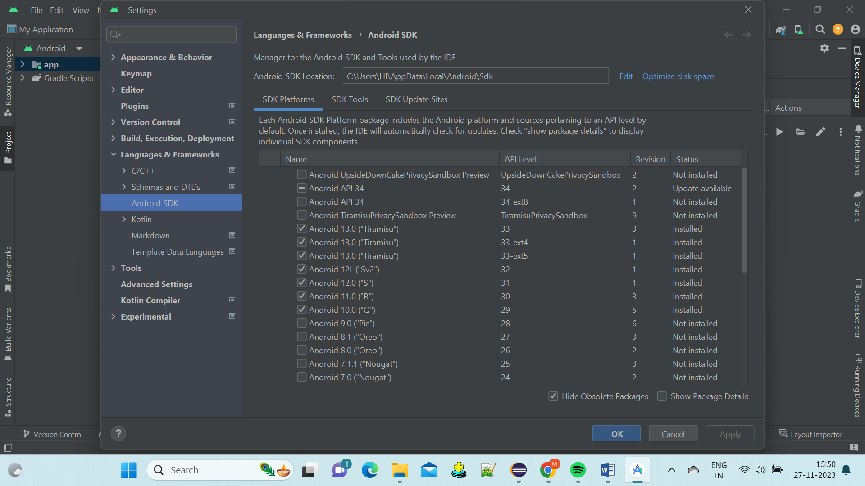

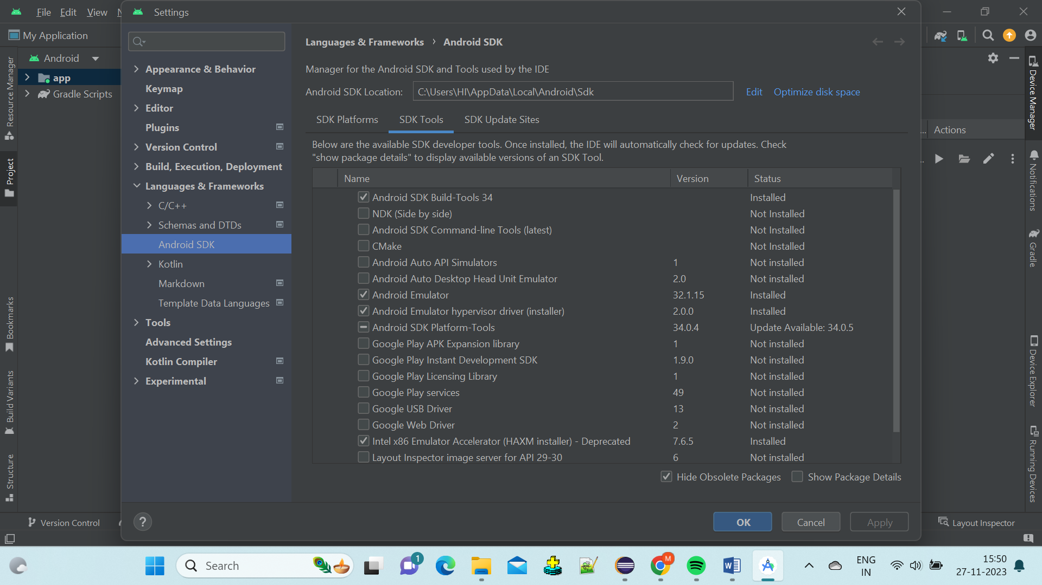

**Emulator Setup: Create AVD and start it**

* Important note: AVDs are resource hungry! Please use a laptop with powerful processor (that supports Intel HAXM/AMD hypervisor) and sufficient RAM.
* Open Android Studio -> Configure -> Virtual Device Manager -> Create Virtual Device ->
* Select Model -> Download Image for desired OS version if not already downloaded
  + Start AVD

**Emulator Setup: Create Driver Session using Appium CLI**

Download link for dummy app:

https://github.com/appium/appium/tree/master/packages/appium/sample-code/apps

**Installing & Starting Appium Server**

* Install GUI Appium Server from the browser directly
* For installing Appium Server via Node we have to use below Commands in CMD

npm install -g appium (It will install Current Stable Version)

npm install -g appium@next (It will install latest Beta Version)(We should prefer this)

N.B. = We should prefer Appium Java Client dependency more than 8.0.0 ( have bugs) in our Maven Project

**Install Appium Inspector**

* + Download and install from <https://github.com/appium/appium-inspector/releases>

**Real Device Setup: Enable USB debugging on Android mobile**

Note: Steps can differ based on the phone manufacturer!

* + Settings -> System -> About Phone -> Click Build Number 7-8 times
  + Settings -> Developer Options -> Enable USB Debugging
  + Permission pop-up: Check the box and press Allow to recognise the computer
  + run "adb devices" in CMD to check if device is recognised
  + USB drivers:

Google: https://developer.android.com/studio/run/win-usb

OEMs: https://developer.android.com/studio/run/oem-usb

**Real Device Setup: Create Driver Session using Appium CLI**

Download link for dummy app:

<https://www.software-testing-tutorials-automation.com/2015/11/test-apps-to-use-in-appium-automation.html>